Dr Carolyn Axtell
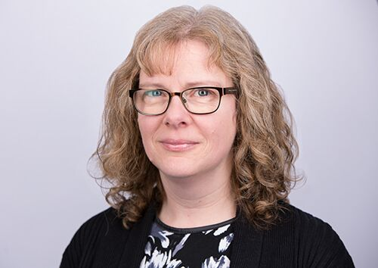
Carolyn is a senior lecturer at the Institute of Work Psychology (within Sheffield University Management School) which has an international reputation for conducting world leading research in the area of Work Psychology.

Carolyn has more than 20 years-worth of experience in conducting research on new ways of working within both the public and private sectors. Her research focusses on various forms of modern working that involve technology, including teleworking, mobile and dispersed teamworking. Carolyn’s core interest is in designing work to promote employee well-being and work-life balance whilst also ensuring employee effectiveness. She is experienced at facilitating work design interventions within organisations and is involved in research examining how interventions and improvement initiatives can be enhanced to have positive effects on employee wellbeing. Carolyn also teaches a course on work-related well-being and uses highly interactive classroom formats to provide students with an effective learning experience.

She has published several papers, reports and chapters in her areas of research and has been invited to speak at several conferences and comment on these subjects within the media. She was recently awarded best paper prize at the Journal of Occupational Health Psychology for her research on a work design intervention, with co-author Prof. David Holman. Carolyn is on the editorial boards of the Journal of Occupational and Organizational Psychology as well as the Journal of Business and Psychology.

